TO FIND THE DISK SIZE BY HUMAN :
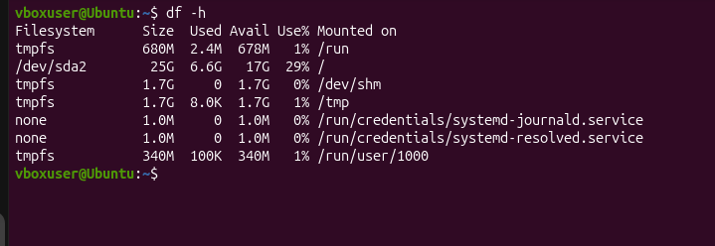

TO FIND THE DISK USAGE OF THE PARTICULAR FILE :
